LAB - Create VNET, Firewall, Subnet, Install VM, Install nginx in VM, end user bypass firewall, Bastion.

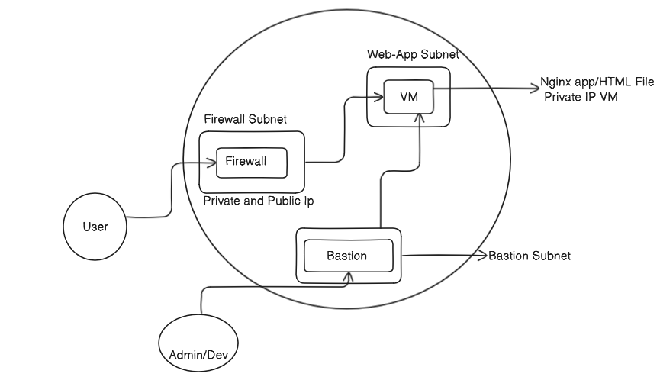

In this LAB, our AIM is to create VNET, in this VNET we created 4 SUBNETS. In each subnet we have placed WebApp/VM, Firewall, Bastion, Firewall Manager Subnet.

Via BASTION connected to VM/Web App and configured NGINX and written a HTML file. We configured Firewall Policy such that the user can able to access the NGINX app/HTML file/VM connecting to the Firewall Public IP and then it will translate to the private IP.

1. Create Resource Group – Satvik

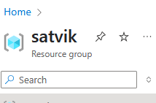

1. Create VNET ‘satvik’

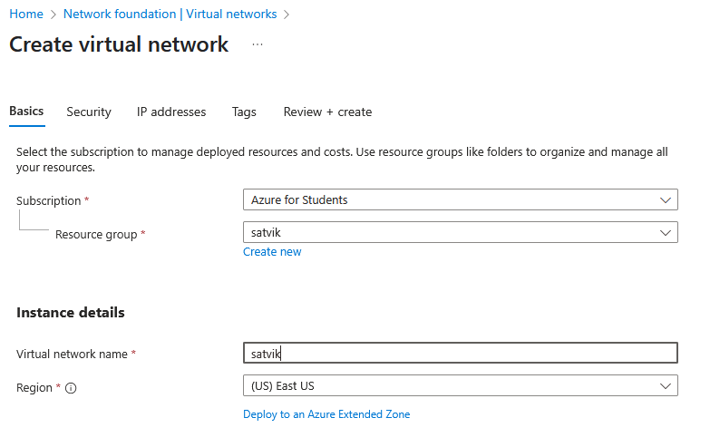

1. Put the below settings

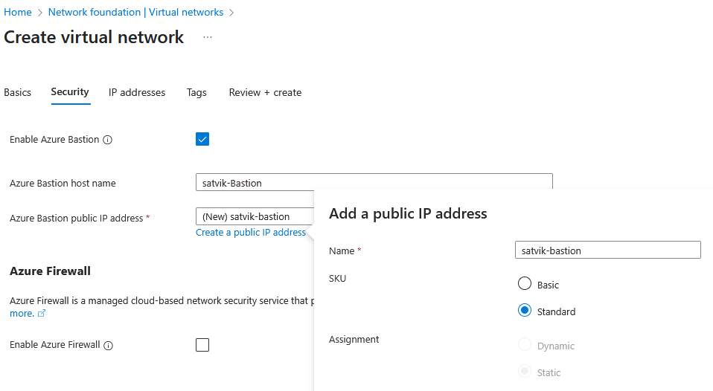

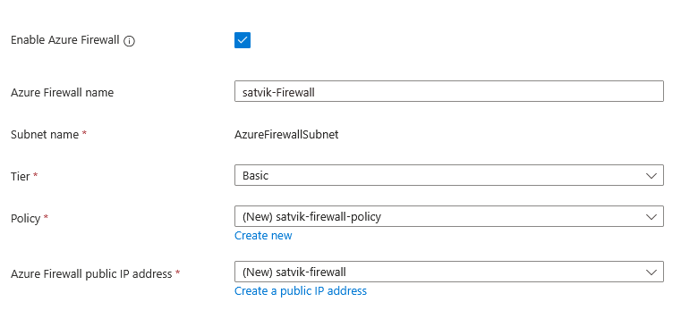

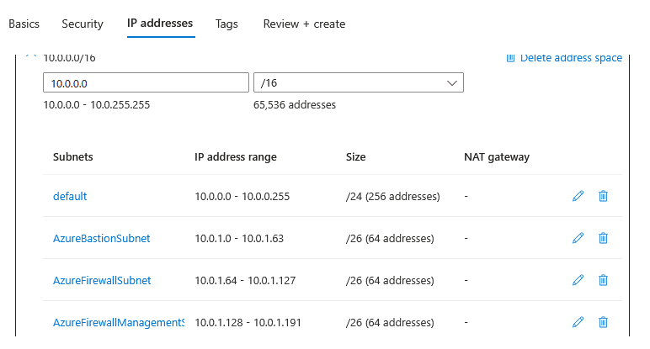

1. Review+Create
2. 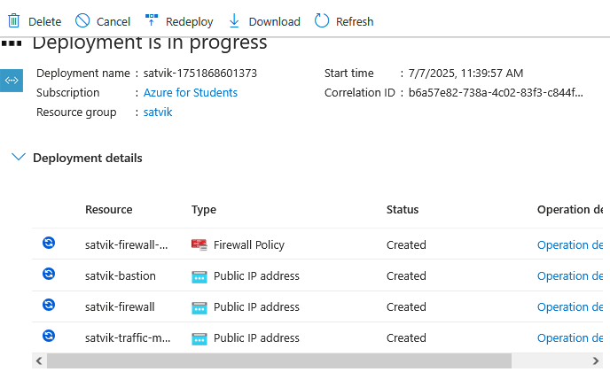
3. Next is to create VM.

Username – azureuser

1. To connect to this VM, use Bastion

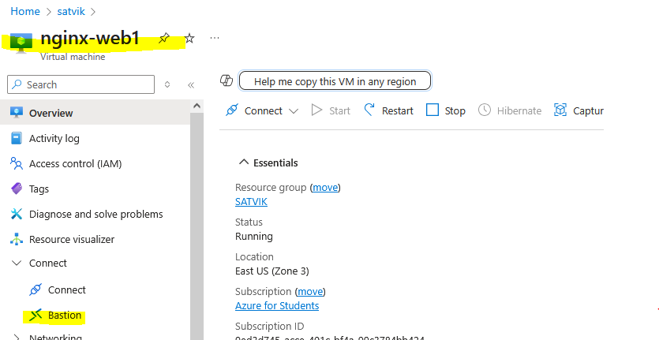

1. Bastion connection settings –

SSH frm private key. Upload PEM file. Username – azureuser

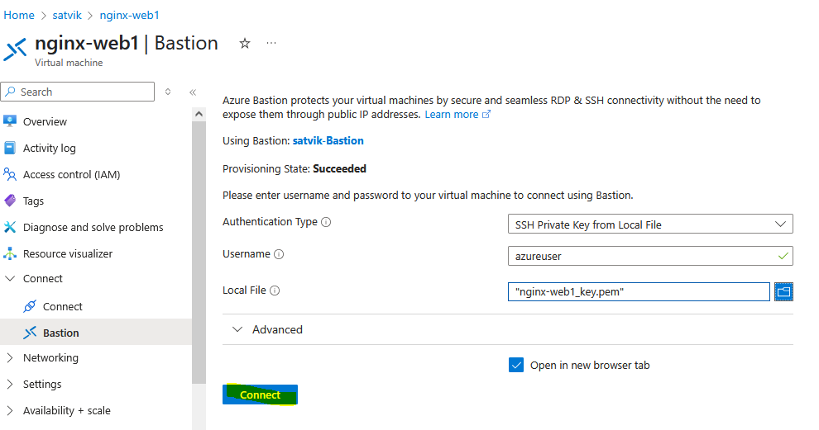

1. Successfully connected to Bastion.

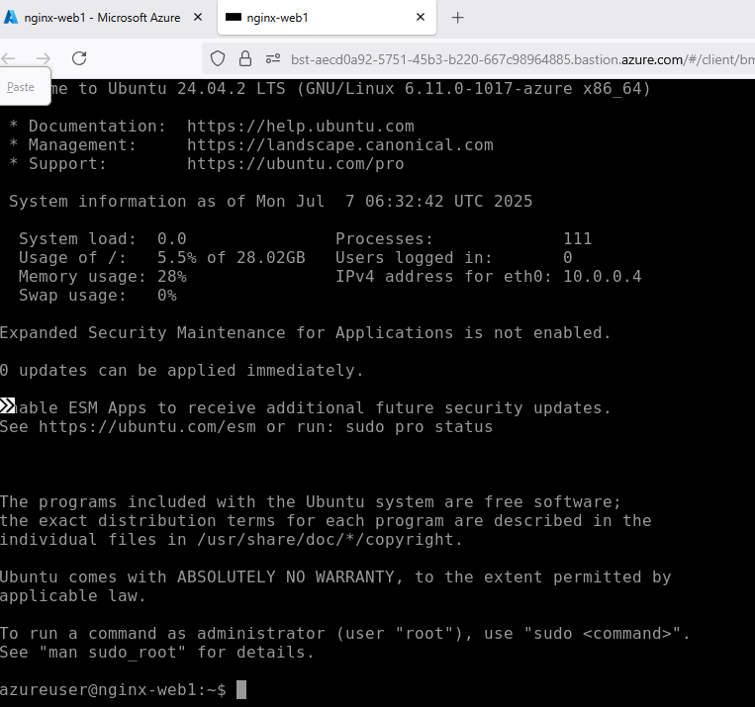

1. Run the below mentioned commands in the host VM.

Sudo su –

Apt-get update

Apt-get install nginx -y

Cd /var/www/html

Ls

Vim index.html

<h1>I learn azure networking today</h1> press ‘i’ in local machine to enter data in file. To save it hit escape in local machine and type ‘:w’ and hit enter.

Systemctl restart nginx

Curl localhost:80

1. Now, its firewall. For a user to access the nginx application in the VM. User will be connecting to firewall and then it will be routed to the VM.
2. Configure the firewall policy in such a way that if some user access this firewall on a particular it will forward the request to the VM/Application. To do that follow the next steps.

FIREWALL:

1. 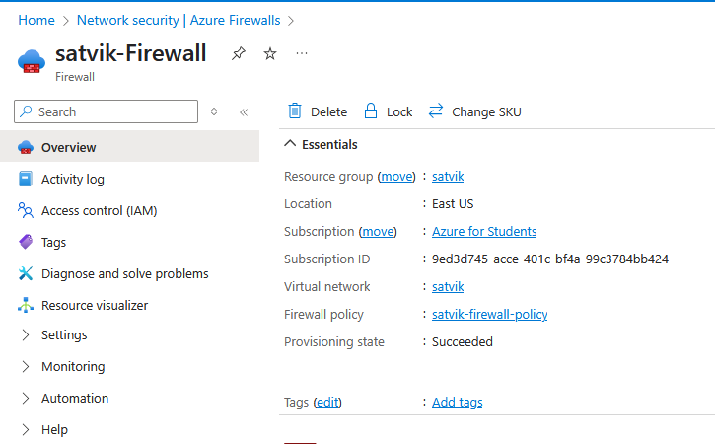
2. Click on the ‘Firewall Policy’.

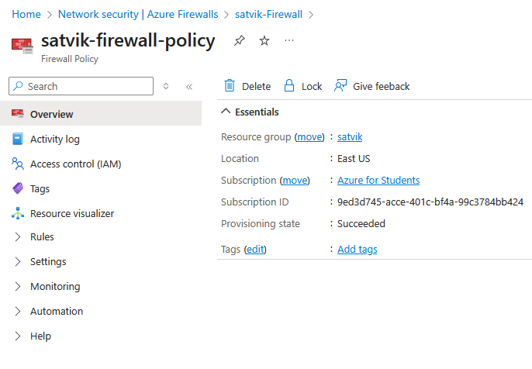

1. DNAT rules

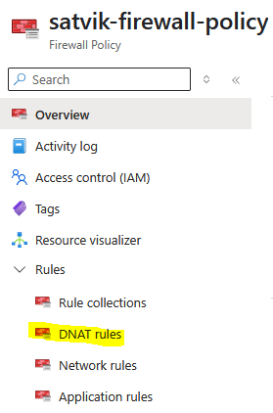

1. Add a rule collection.

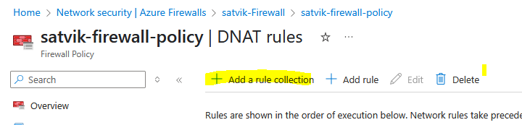

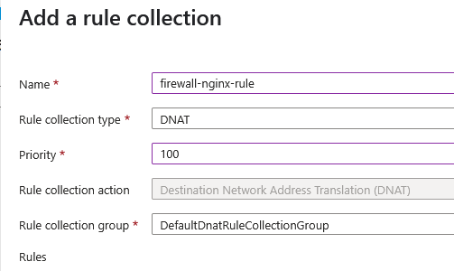

Click ADD.

Name – nginx-rule

SourceType – IP Address (User Local Machine)

Destination IP (Firewall Public IP)

TCP Protocol, Destination Port Number – 4000, Translated IP is Private IP of VM and port of nginx Application

1. IP - 49.43.216.80

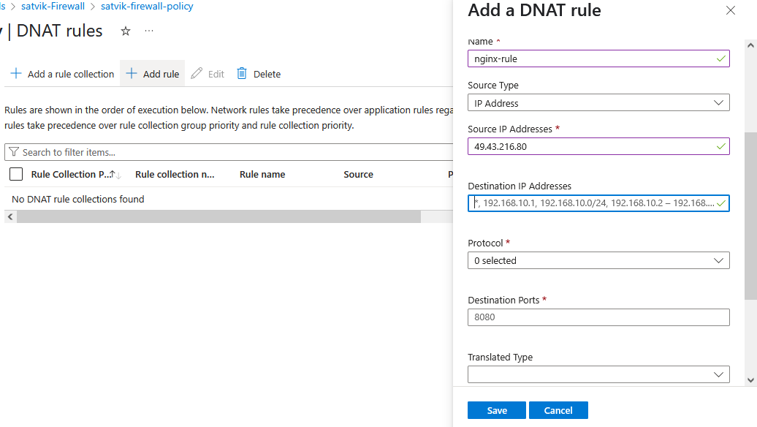

1. Able to access the html file in nginx application server.

